**THE PARIS OPERA HOUSE**

**Comprehension Check 1 (page 54)**

**1.**Napoleon III.

**2.**Classical, Renaissance and Baroque.

**3.**Such as the Emperor could drive directly into the main hall of the Opera.

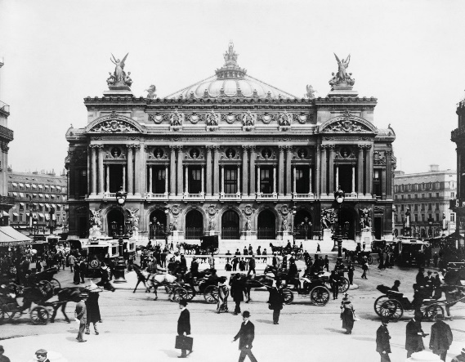**4.**Because of the war of 1870 and the fire in 1873.

**5.**Baron Haussmann.

**6.**To make the foundations of the Opera safe.

**7.**Lyric Drama, Lyric Poetry, Dance and Music.

**By: Helena Rabasa.**