https://fontmeme.com/temporary/0e9c7e11bf9bda9011c688e197c777ef.png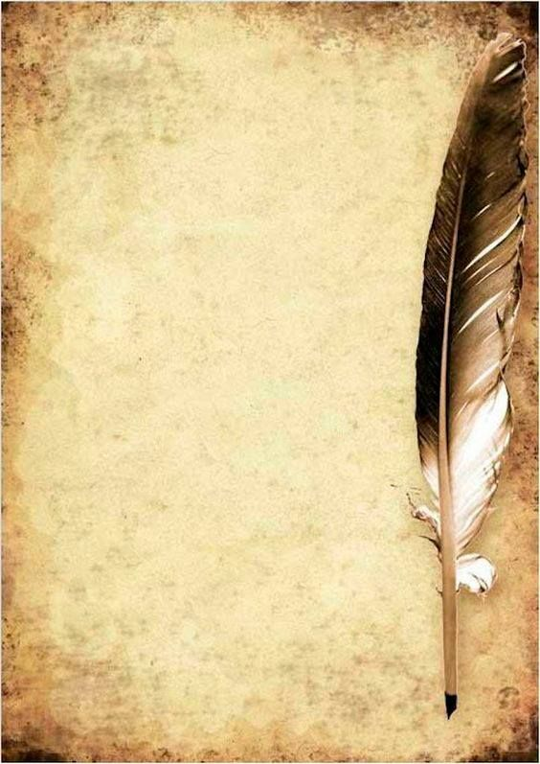

Dear personal diary,

I will start writing here explaining my story.

My name it’s Christine Daae. I was born just outside the Swedish city of Uppsala, in a small market-town. My father was a farmer who also sang in the church choir, known far and wide for his incredible talent with a violin. My mother died when I was 6 years old and I was brought up by my father, who after selling his land, traveled with me to Uppsala in search of musical fame and fortune. We found only poverty, and we eventually traveled to fairs where my father played the violin and I sang. We were discovered at the Ljimby Fair by Professor Valerius, who toke us to Gothenburg and then to Paris, providing for my education and my musical instruction.

During the summers, we stayed in a summer house in Perros-Guirec, in the Breton region of France, as a means of helping my father with his homesickness and longing for Sweden. I was extremely closed to my father, who told me Scandinavian fairy tales, a tale of the “Angel of Music” was my favorite. It’s during a summer visit in Perros when I met Raoul de Chagny, who rescued my red scarf when it flies into the sea. Now, we’re in love.

Well, until next time.

I promise I’ll write here every day.

Best wishes.